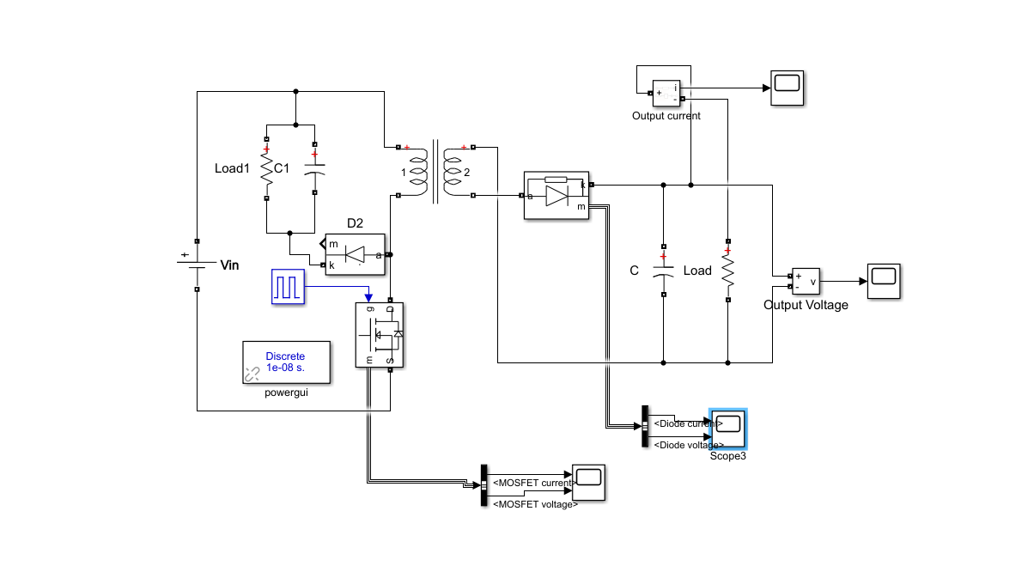

Figure: The circuit schematic of flyback converter with snubber

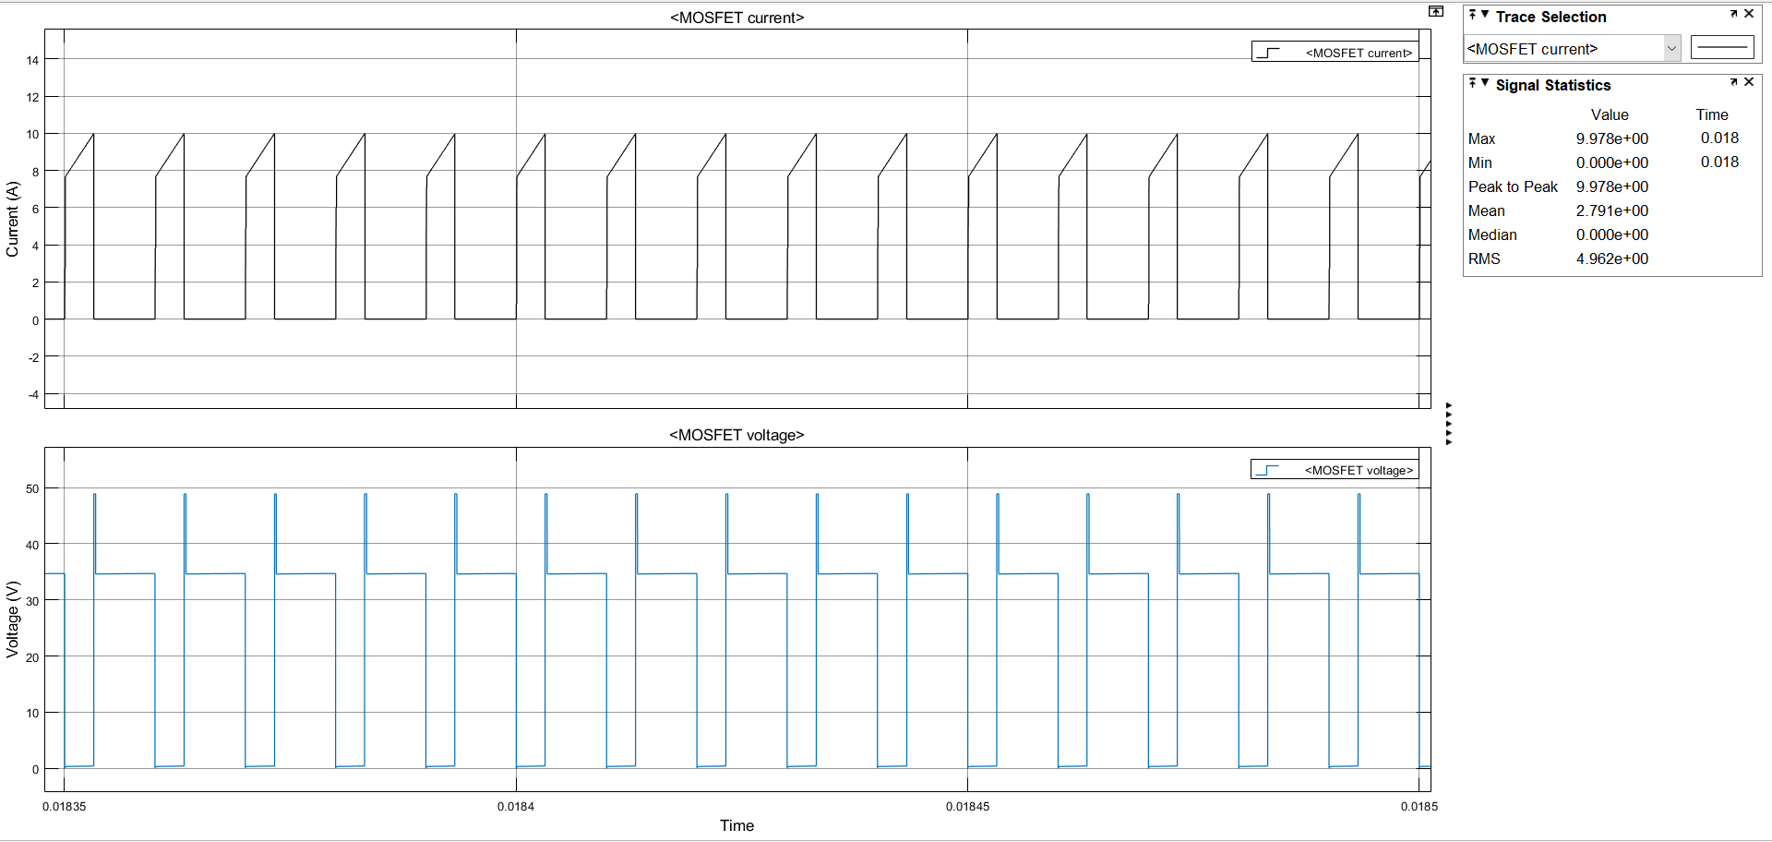

Figure: Simulation results of voltage and current waveforms for MOSFET

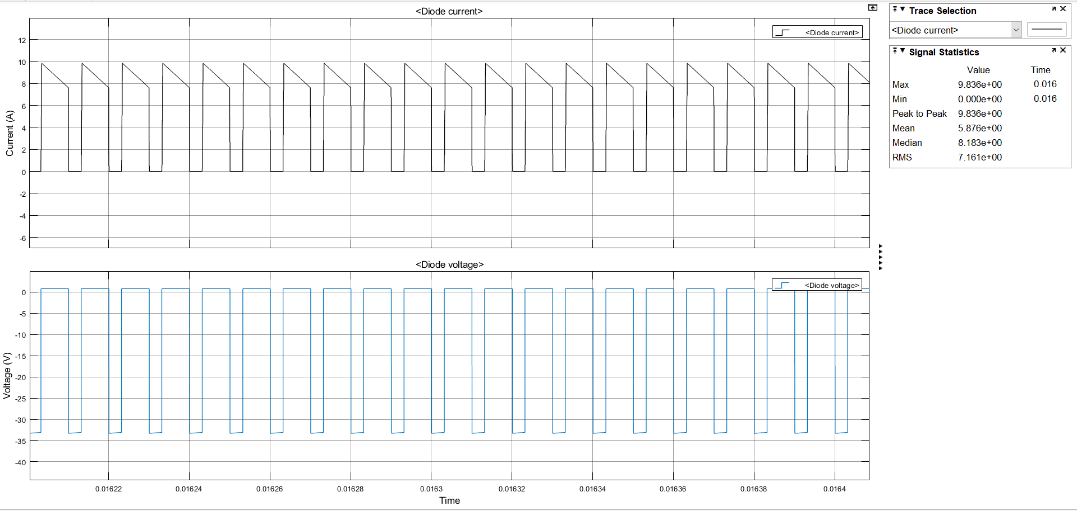

Figure: Simulation results of voltage and current waveforms for diode in the secondary side

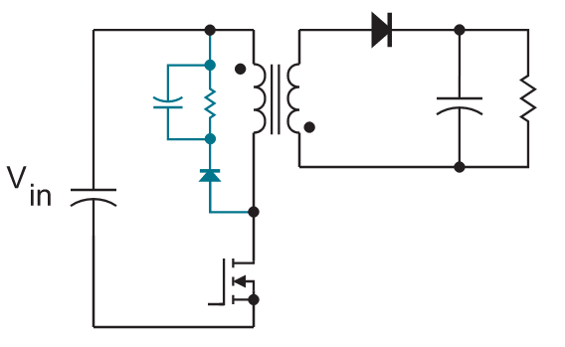

Figure: Flyback Converter Snubber

For the snubber,

$$R = 220 Ω$$

$$C=47 μF$$